
Thermal Vacuum Test Report for AAU-Cubesat

Purpose
The purpose of this test is to demonstrate that the AAU-cubesat flight-model is able to survive the thermal and pressure conditions experienced throughout launch and deployment with the Rockot launcher.

Date, Place, and Personnel
The test will be performed in house using the thermal vacuum chamber developed for the Ørsted project. The test will be performed on the 11th and 12th of March. Test personnel from the AAU-cubesat team will be:
Tor Viscor (Responsible for test equipment)
Morten Bisgaard (Responsible for test operations)

Equipment
The following equipment will be needed:
- Thermal Vacuum chamber
- Thermal connection foil test
- Fixture for vacuum chamber mounting
- Lap-top for telemetry acquisition
- Umbilical connectors (DSUB9)
- Special built battery charger

Procedure
The following described the procedure to be followed before, during and after the test.

Mounting and pre-test procedures:
- Satellite is placed on a sheet of thermal connection foil on the fixture with the pay-load plate downwards
- Provisions to make the best possible thermal contact is made without compromising the integrity of the solar panels
- Connectors are connected to the access ports on the satellite and connecting to internal connectors in vacuum chamber
- Vacuum chamber is closed and connection from vacuum chamber external connectors is connected to laptop and powersupply.
- Satellite is turned on and a simple functionality test is performed (telemetry return)

Test procedure:
- Verify that the satellite is turned off
- Depressurise chamber
- When pressure drops below 0.01 Torr then turn on satellite (Corona Effect) and perform functional test
- Upload flight-plan to issue system wide GetStatus commands every two minutes
- The temperature of the controlled pate is increased to 85 degrees (Celsius)
- The temperature remains at 85 for until all temperature sensors are within 33% of the target temperature
- The temperature of the controlled plate is decreased to -30 degrees
- The temperature remains at -30 until all temperature sensors are within 33% of the target temperature
- The temperature is increased to 20 degrees
- The temperature remains at 20 until all temperature sensors are within 33% of the target temperature
- Satellite is turned off
- Chamber is pressurised. Test completed.

During the test log-data from the satellite should periodically be downloaded to the laptop and be stored in the database, using the serial interface.

If time allows then the test should be extended by cycling through points 5-9 as many times as possible within the available timeframe.

Post-test procedure:
- Open chamber. Disconnect connectors
- Full functional test of the satellite is performed
- The payload plate is removed from the satellite and the satellite is inspected for any structural damage as thoroughly as possible, without further disassembly

Results
Temperature graphs of all temperature sensors are produced and enclosed with this report. Each graph must include a designation of the sensor position. This document together with the graphs is sent to: Robert Zee (SPL) and Per Lundahl (DRI).

TEST REPORT

Incidents
During the warm up phase one of the temperature controlling elements broke. This means that it was impossible to go below – 10 degrees during the cold phase. Therefore it was impossible to test the satellite against the specified levels.

Data
The following figure shows the graphs recorded from all temperature sensors in the satellite. For brevity only the warm and low part of the graph is shown (separated by the discontinuity). Temperatures are considered accurate within +/- 2 degrees Celsius.

The two pictures at the end of the document show the test equipment used.
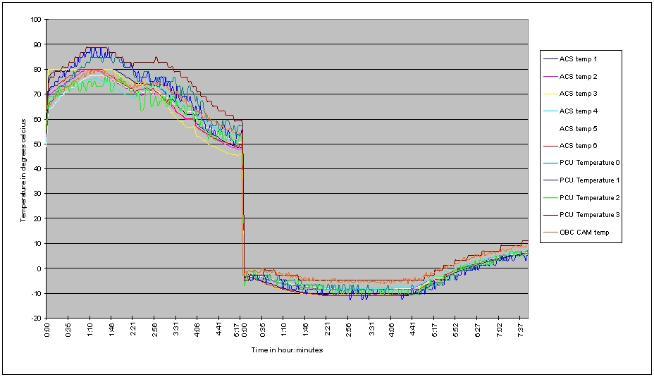

Conclusion
The satellite was not tested against the specified levels, but it performed without any problems in the vacuum environment in the temperature range from -10 to 85 degrees Celsius.

The most critical components with regard to temperature environment are the batteries. These have been thoroughly tested in the full specified range (-30-85 degrees) prior to integration of subsystems. No problems are therefore expected for temperature below the –10 degrees that was the limit in this test.

